EXPERIMENT NO. 03
SIMULATION AND ANALYSIS OF 2-INPUT CMOS NAND AND NOR GATES
―――――――――――――――――――――――――――――――――――――――――――――――――――――――
AIM
To simulate and analyze the schematics and transient waveforms of 2-input CMOS NAND and NOR gates using LT Spice.
SOFTWARE USED
LT Spice
CIRCUIT DIAGRAM
The schematic diagrams for 2-input NAND and NOR gates:
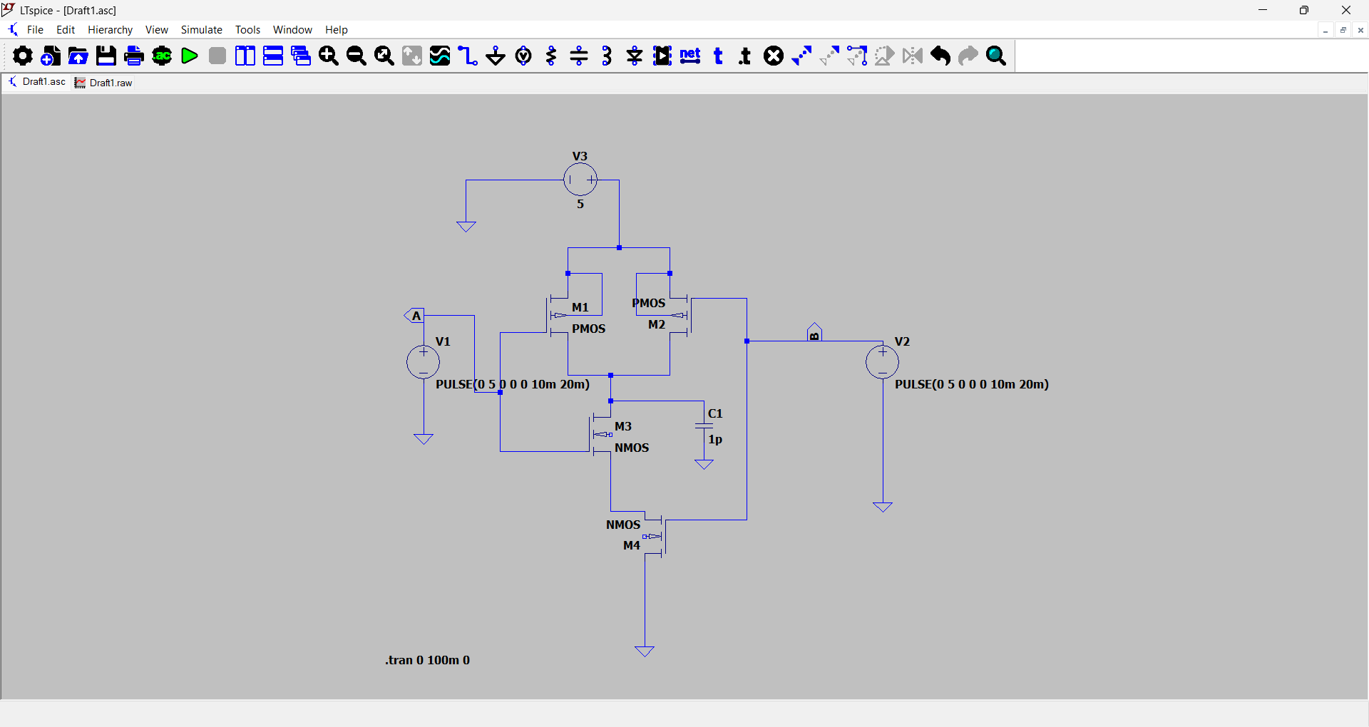
Figure 3.1: LT Spice Schematic of 2-Input CMOS NAND Gate
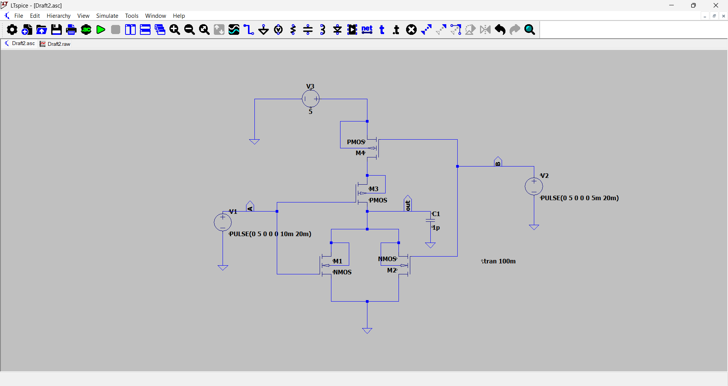
Figure 3.2: LT Spice Schematic of 2-Input CMOS NOR Gate
Transistor architecture of 2-input CMOS NAND gate:
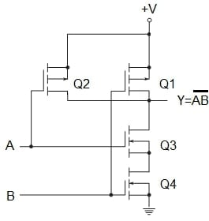
Figure 3.3: CMOS Two-Input NAND Gate Structure
SMALL THEORY
NAND and NOR gates are universal logic gates realized using static complementary CMOS logic, comprising a Pull-Up Network (PUN) of PMOS transistors and a Pull-Down Network (PDN) of NMOS transistors.
1. 2-Input CMOS NAND Gate:
- Circuit Architecture: PUN consists of two PMOS transistors (Q1, Q2) connected in parallel between VDD and output. PDN consists of two NMOS transistors (Q3, Q4) connected in series between output and ground.
- Operation: Output is LOW (0) only when both inputs A and B are HIGH (1), activating both series NMOS devices. When either input is LOW (0), at least one parallel PMOS conducts, pulling the output HIGH (1).
Truth Table for 2-Input NAND Gate:
Input A | Input B | Output Y (NAND)
0 | 0 | 1
0 | 1 | 1
1 | 0 | 1
1 | 1 | 0

2. 2-Input CMOS NOR Gate:
- Circuit Architecture: PUN consists of two PMOS transistors connected in series between VDD and output. PDN consists of two NMOS transistors connected in parallel between output and ground.
- Operation: Output is HIGH (1) only when both inputs A and B are LOW (0), conducting through both series PMOS devices. When either input is HIGH (1), a parallel NMOS conducts, pulling the output LOW (0).
Truth Table for 2-Input NOR Gate:
Input A | Input B | Output Y (NOR)
0 | 0 | 1
0 | 1 | 0
1 | 0 | 0
1 | 1 | 0

OUTPUT GRAPH
Simulated transient waveforms from LT Spice:
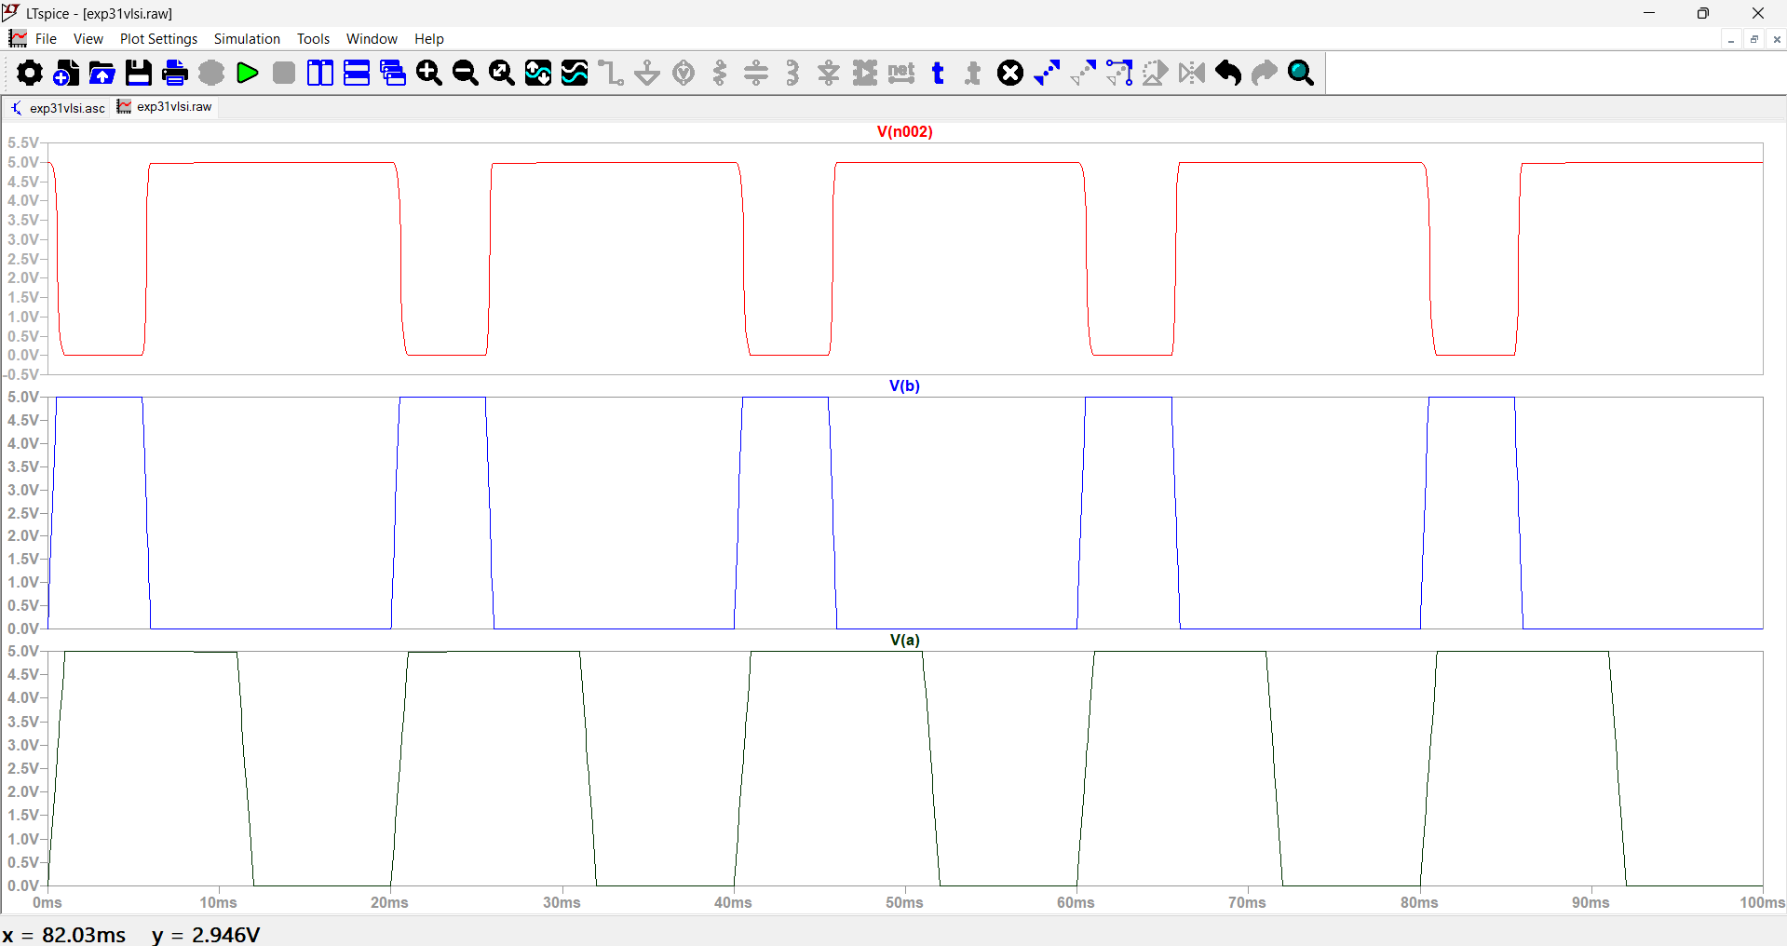
Figure 3.4: Simulated Output Waveforms of 2-Input CMOS NAND Gate
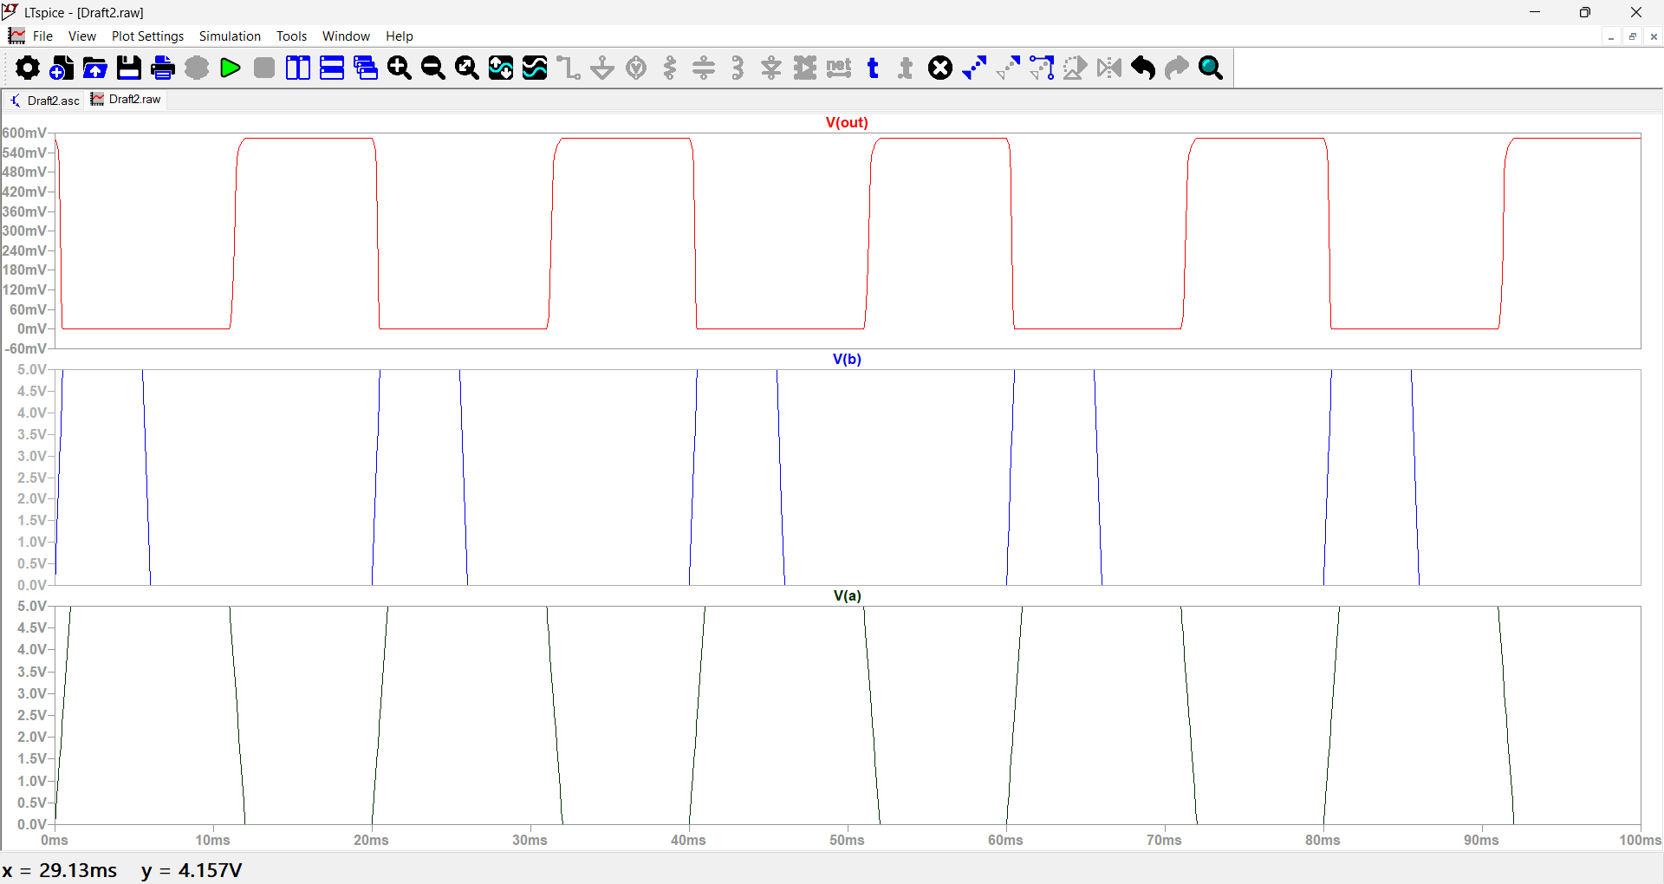
Figure 3.5: Simulated Output Waveforms of 2-Input CMOS NOR Gate

